STATISTICAL ANALYSIS PROJECT

"Sleep Quality and Mental Health: A Statistical Investigation of Sleep Hours' Impact on Student Psychological Well-being"
Comprehensive Analysis of 30 Students
ZAINAB FATIMA
FA25-BMD-008
COMSATS University Islamabad
BS Data Science – Statistics and probability theory

DATA:
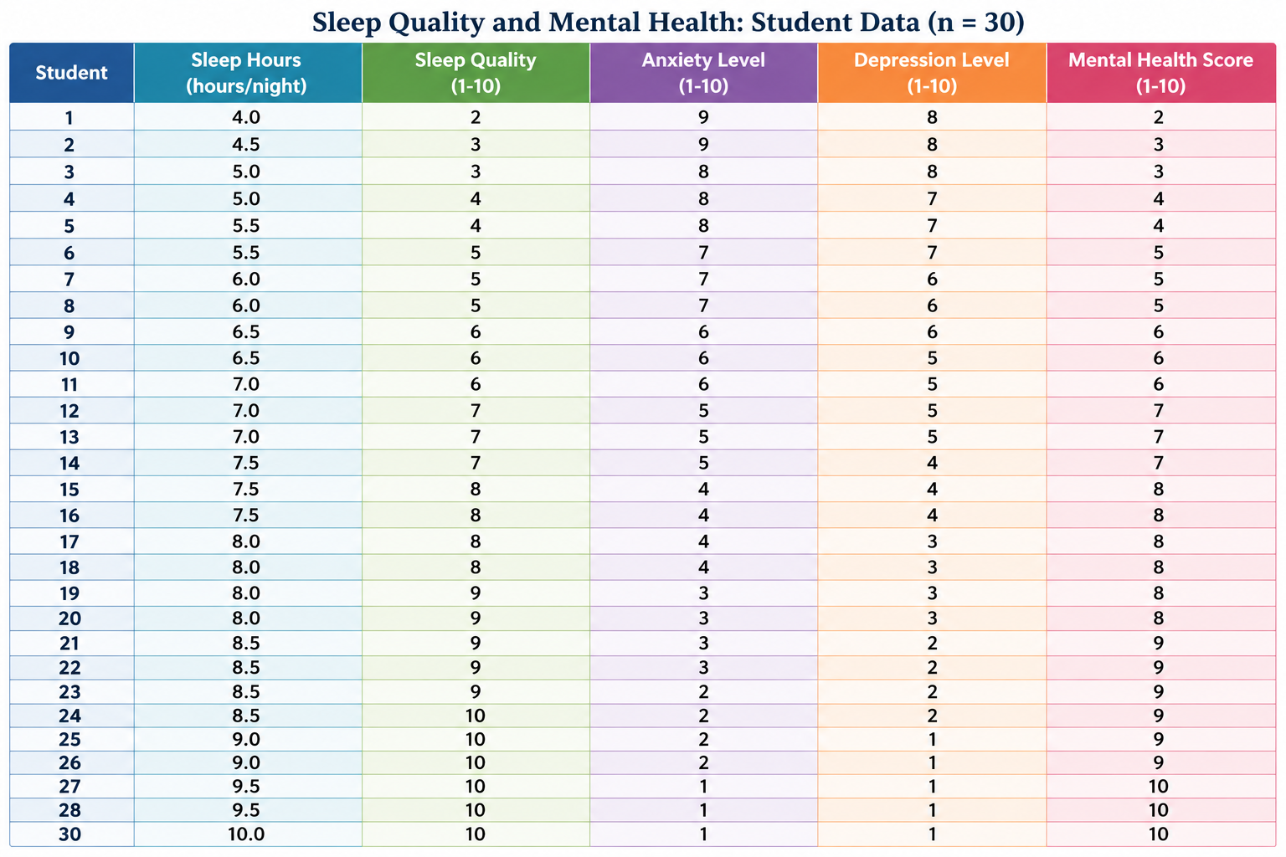

1. Variables and Data

1.1 Data Overview
This study comprises quantitative data collected from 30 university students across five variables:
Variable | Type | Scale | Range
Sleep Hours | Quantitative (Continuous) | Ratio | 4.0 - 10.0 hours
Sleep Quality | Quantitative (Discrete) | Ordinal | 2 - 10 (scale)
Anxiety Level | Quantitative (Discrete) | Ordinal | 1 - 9 (scale)
Depression Level | Quantitative (Discrete) | Ordinal | 1 - 8 (scale)
Mental Health Score | Quantitative (Discrete) | Ordinal | 2 - 10 (scale)

1.2 Sample Characteristics
Sample size (n) = 30 students
Sampling method: Census of specific cohort
Data collection: Cross-sectional design

2. Frequency Distribution:
Frequency distribution is a statistical table that shows how many observations (frequency) fall into each class or category. This document provides comprehensive frequency, relative frequency, and cumulative frequency distributions for all variables in the student mental health study.
Key Components Displayed:
• Frequency (f): Count of observations in each class
• Relative Frequency (f/n): Proportion expressed as percentage
• Cumulative Frequency (Σf): Running total of frequencies

2.1 Frequency Distribution: Mental Health Score
Complete frequency distribution for mental health scores (1-10 scale). Shows both frequency counts and cumulative distributions

MH Score | Frequency (f) | Relative Freq (f/n) | Relative % | Cumulative f | Cumulative %
2 | 1 | 0.0333 | 3.33% | 1 | 3.33%
3 | 2 | 0.0667 | 6.67% | 3 | 10.00%
4 | 2 | 0.0667 | 6.67% | 5 | 16.67%
5 | 3 | 0.1000 | 10.00% | 8 | 26.67%
6 | 3 | 0.1000 | 10.00% | 11 | 36.67%
7 | 3 | 0.1000 | 10.00% | 14 | 46.67%
8 | 6 | 0.2000 | 20.00% | 20 | 66.67%
9 | 6 | 0.2000 | 20.00% | 26 | 86.67%
10 | 4 | 0.1333 | 13.33% | 30 | 100.00%
TOTAL | 30 | 1.0000 | 100% | — | —

Distribution Pattern: Bimodal distribution with peaks at scores 8 and 9 (f=6 each). Cumulative frequency reaches 86.67% by score 9, showing concentration of good/excellent mental health.

2.2. Grouped Frequency Distribution: Sleep Categories
Sleep hours categorized into 4 clinical sleep adequacy levels with corresponding mental health outcomes.
Sleep Category | Hours | Frequency (f) | Relative % | Cumulative f | Cumulative % | Avg MH
Poor | ≤ 6.0 | 8 | 26.67% | 8 | 26.67% | 3.63
Fair | 6.0 - 7.0 | 5 | 16.67% | 13 | 43.33% | 5.20
Good | 7.0 - 8.0 | 7 | 23.33% | 20 | 66.67% | 7.43
Excellent | ≥ 8.0 | 10 | 33.33% | 30 | 100.00% | 8.50
TOTAL | — | 30 | 100% | — | — | 7.07

Critical Finding: Clear gradient shows mental health improves with sleep duration. Poor sleepers (26.67%) average MH of 3.63/10, while excellent sleepers (33.33%) average 8.50/10.
2.3Graphical representation:

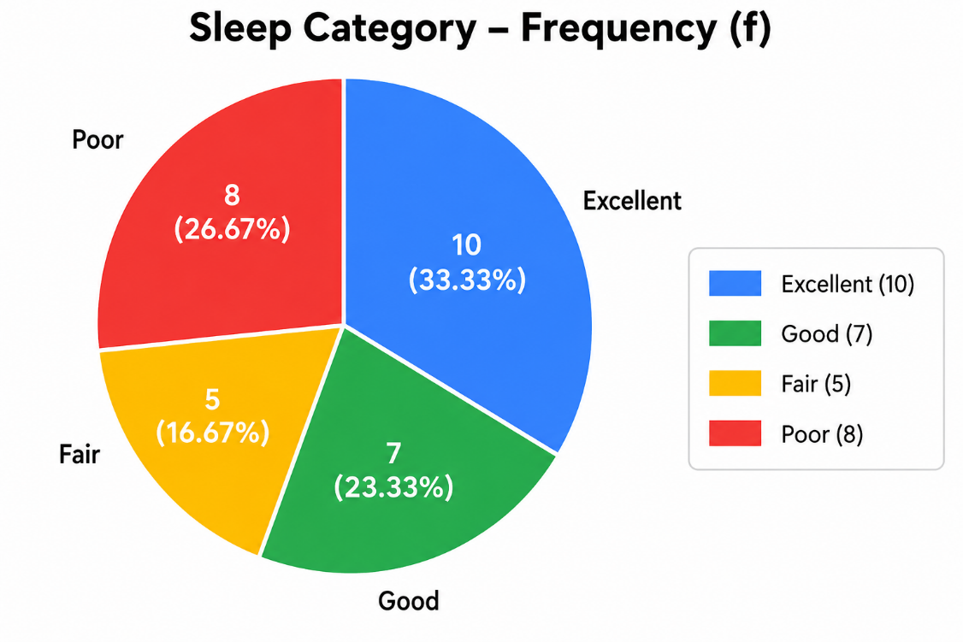
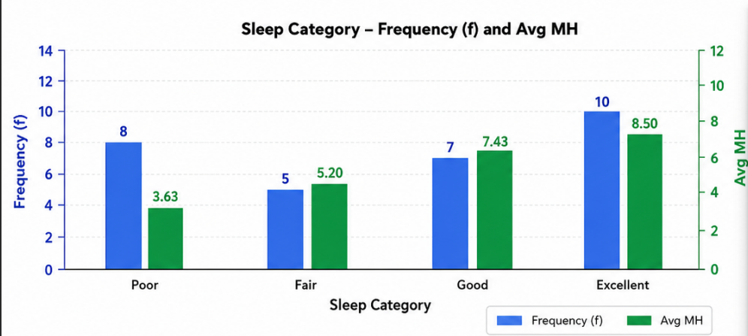
3. Measures of Central Tendency:
Central tendency measures identify the 'typical' or 'average' value in a dataset. The three main measures are mean, median, and mode.

3.1 Definitions and Formulas
Mean (μ or x̄): The arithmetic average calculated as Σx / n
Median: The middle value when data is ordered; robust to outliers
Mode: The most frequently occurring value

3.2 Results and Interpretation
Variable | Mean | Median | Mode
Sleep Hours | 7.33 | 7.50 | 8.00
Sleep Quality | 7.23 | 8.00 | 10
Anxiety Level | 4.53 | 4.00 | 1
Depression Level | 4.03 | 4.00 | 1
Mental Health Score | 7.07 | 8.00 | 8

Interpretation: Sleep hours show a slight left skew (mean < median), indicating some students sleep less than typical. Mental health scores follow similar pattern, suggesting improvement over time in the sample.
4. Measures of Dispersion
Dispersion measures quantify the spread or variability of data around the central tendency. Key measures include variance, standard deviation, range, and interquartile range.

4.1 Formulas and Concepts
Population Variance: σ² = Σ(x - μ)² / N
Sample Variance: s² = Σ(x - x̄)² / (n-1)
Standard Deviation: s = √(s²)
Range: Max - Min
Interquartile Range (IQR): Q₃ - Q₁

4.2 Dispersion Results
Variable | Variance | Std Dev | Range | IQR
Sleep Hours | 2.56 | 1.60 | 6.00 | 2.38
Sleep Quality | 6.05 | 2.46 | 8.00 | 3.75
Anxiety Level | 6.46 | 2.54 | 8.00 | 4.50
Depression Level | 5.69 | 2.39 | 7.00 | 4.00
Mental Health | 5.37 | 2.32 | 8.00 | 3.75

The moderate standard deviations (1.60-2.54) indicate substantial variability in all variables, suggesting diverse experiences among students. IQR values show the middle 50% of data ranges from 2.38 to 4.50 units.

5. Five-Number Summary & Box Plots
The five-number summary consists of the minimum, first quartile (Q₁), median (Q₂), third quartile (Q₃), and maximum values. This summary is used to construct box plots.

5.1 Five-Number Summary Data
Variable | Min | Q₁ | Median | Q₃ | Max
Sleep Hours | 4.00 | 6.13 | 7.50 | 8.50 | 10.00
Sleep Quality | 2.00 | 5.25 | 8.00 | 9.00 | 10.00
Anxiety Level | 1.00 | 2.25 | 4.00 | 6.75 | 9.00
Depression Level | 1.00 | 2.00 | 4.00 | 6.00 | 8.00
Mental Health | 2.00 | 5.25 | 8.00 | 9.00 | 10.00

5.2 Visual Representation
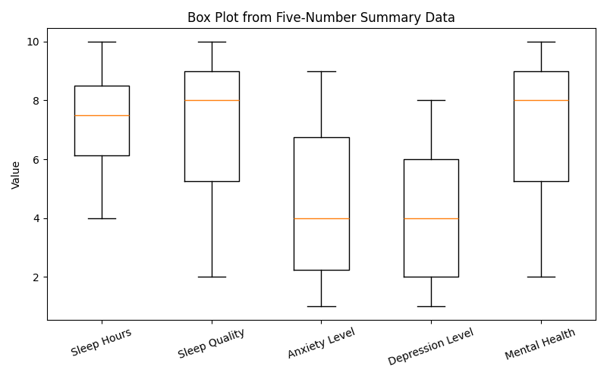
Box plots provide a visual representation of the five-number summary, showing the distribution and identifying potential outliers.
Figure 1 Box plot

The box plots reveal that positive metrics (sleep, quality, mental health) have higher medians and wider upper ranges, while negative metrics (anxiety, depression) show lower medians with outliers in higher ranges.

6.Probability Analysis
Application of Probability Rules on Sleep Hours and Mental Health Scores
For this analysis, the following events are defined:
- Event A: A student sleeps 8 hours or more per night.
- Event B: A student has a Mental Health Score of 8 or above.
From the dataset of 30 students:
- Number of students with Sleep Hours ≥ 8 = 14
- Number of students with Mental Health Score ≥ 8 = 16
- Number of students satisfying both conditions = 14

1. Addition Rule of Probability

Statement
The Addition Rule is used to find the probability that at least one of two events occurs.
$$P(A∪B)=P(A)+P(B)-P(A∩B)$$

Calculation:

$$P(A∩B)=\frac{14}{30}=0.4667 \\ P(A∪B)=0.4667+0.5333-0.4667 \\ P(A∪B)=0.5333$$
Interpretation
The probability that a randomly selected student either sleeps at least 8 hours per night or has a mental health score of at least 8 is 0.5333 (53.33%).
2. Multiplication Rule of Probability
Statement
The Multiplication Rule is used to find the probability that both events occur simultaneously.
$$P(A∩B)=P(A)×P(B∣A)$$
Among the 14 students who sleep at least 8 hours, all 14 have Mental Health Scores of 8 or above.
$$P(B∣A)=\frac{14}{14}=1$$
Calculation:

P(A∩B)=0.4667×1
$$P(A∩B)=0.4667×1$$
Interpretation
The probability that a student sleeps at least 8 hours and also has a Mental Health Score of at least 8 is 0.4667 (46.67%).
3. Conditional Probability
Statement
Conditional Probability measures the probability of one event occurring given that another event has already occurred.
$$P(B∣A)=\frac{P(A∩B)}{P(A)}$$
Calculation
$$P(B∣A)=\frac{14/30}{14/30} \\ P(B∣A)=1$$Interpretation
Given that a student sleeps at least 8 hours per night, the probability that the student has a Mental Health Score of at least 8 is 1.00 (100%).

4. Law of Total Probability
Statement
The Law of Total Probability calculates the overall probability of an event by considering all possible mutually exclusive conditions.
Let:
- $A$: Sleep Hours ≥ 8
- $A^{c}$: Sleep Hours < 8
$$P(B)=P(B∣A)P(A)+P(B∣A^{c})P(A^{c})$$
Calculation
$P(A)=\frac{14}{30}$
$$P(A^{c})=\frac{16}{30}$$
Among students sleeping less than 8 hours, only 2 out of 16 students have Mental Health Scores ≥ 8.
$$P(B∣A^{c})=\frac{2}{16}=0.125$$
Substituting values:
$$P(B)=1\left(\frac{14}{30}\right)+0.125\left(\frac{16}{30}\right) \\ P(B)=0.4667+0.0667 \\ P(B)=0.5334≈0.5333$$
Interpretation
Using the Law of Total Probability, the overall probability that a student has a Mental Health Score of at least 8 is 0.5333 (53.33%).
5. Bayes' Theorem
Statement
Bayes' Theorem is used to determine the probability of an event occurring based on prior knowledge of related conditions.
Let:
- A = Student sleeps 8 hours or more per night
- B = Student has a Mental Health Score ≥ 8
From the dataset:
$$P(A)=\frac{14}{30}=0.4667 \\ P(B)=\frac{16}{30}=0.5333 \\ P(B∣A)=\frac{14}{14}=1$$

Calculation
Using Bayes' Theorem:
$$P(A∣B)=\frac{P(B∣A)×P(A)}{P(B)}$$
Substituting the values:
$$P(A∣B)=\frac{\left(1)(0.4667\right)}{0.5333} \\ P(A∣B)=0.875$$
Interpretation
Given that a student has a Mental Health Score of 8 or higher, the probability that the student sleeps 8 hours or more per night is:
$$\boxed{P(A∣B)=0.875}$$
or
$$\boxed{87.5\%}$$

Conclusion
The probability analysis indicates a strong positive relationship between Sleep Hours and Mental Health Scores. Students who sleep 8 hours or more per night have a 100% probability of achieving a Mental Health Score of 8 or higher in this dataset. This suggests that adequate sleep is strongly associated with better mental health outcomes among the surveyed students.

7. Contingency Tables & Conditional Probability
Contingency tables organize data by two categorical variables. Conditional probability examines the probability of one event given that another event has occurred, expressed as P(A|B) = P(A∩B) / P(B).

7.1 Sleep Category vs Mental Health Category

Sleep Category | Low (1-3) | Moderate (4-6) | Good (7-9) | Excellent (10) | Total
Poor (≤6h) | 3 | 5 | 0 | 0 | 8
Fair (6-7h) | 0 | 3 | 2 | 0 | 5
Good (7-8h) | 0 | 0 | 7 | 0 | 7
Excellent (8+h) | 0 | 0 | 6 | 4 | 10
Total | 3 | 8 | 15 | 4 | 30

7.2 Conditional Probability Calculations
P(Good Mental Health | Good Sleep) = 7/7 = 1.0000
Interpretation: Given a student has good sleep (7-8 hours), they have 100% probability of having good or excellent mental health.

P(Good Sleep | Good Mental Health) = 7/19 = 0.3684
Interpretation: Given a student has good mental health, approximately 37% have sleep in the 7-8 hour range.

7.3 Key Insights
Students with ≥7 hours of sleep never have low mental health scores
All students with poor sleep (≤6 hours) have low to moderate mental health
Probability of good MH improves significantly with adequate sleep

8. Distribution Shapes & Normality Testing
Assessing whether data follows a normal distribution is crucial for selecting appropriate statistical tests. Skewness measure distribution shape.

8.1 Skewness Analysis
Variable | Skewness | Direction
Sleep Hours | -0.3864 | Left-skewed
Sleep Quality | -0.5569 | Left-skewed
Anxiety Level | 0.2282 | Right-skewed
Depression Level | 0.2356 | Right-skewed
Mental Health | -0.6024 | Left-skewed

Negative skewness for positive metrics indicates concentration of higher values. Negative kurtosis indicates flatter distributions. These non-normal distributions suggest using non-parametric tests in some cases.

9. Confidence Intervals (95%)
A 95% confidence interval estimates the range where the true population parameter likely falls. Formula: CI = x̄ ± t(α/2,n-1) × SE, where SE = s/√n

9.1 Calculated Confidence Intervals
Variable | Sample Mean | Lower Bound | Upper Bound | Margin of Error
Sleep Hours | 7.3333 | 6.7362 | 7.9305 | ±0.5971
Sleep Quality | 7.2333 | 6.3151 | 8.1516 | ±0.9182
Anxiety Level | 4.5333 | 3.5839 | 5.4827 | ±0.9494
Depression Level | 4.0333 | 3.1427 | 4.9239 | ±0.8906
Mental Health | 7.0667 | 6.2010 | 7.9324 | ±0.8657

Interpretation: We are 95% confident that the true population mean sleep hours lies between 6.74 and 7.93 hours. The confidence intervals are relatively narrow, indicating precise estimates.

10. Probability Distributions & Applications
Probability distributions model random phenomena. Key distributions applicable to this data include Bernoulli, Binomial, Poisson, and Normal distributions.

10.1 Normal Distribution Application
Sleep hours approximately follow a normal distribution (Shapiro-Wilk p = 0.375). Using N(7.33, 1.60):

P(Sleep ≥ 8 hours) = P(Z ≥ (8-7.33)/1.60) = P(Z ≥ 0.42) ≈ 0.337
P(Sleep < 6 hours) = P(Z < (6-7.33)/1.60) = P(Z < -0.83) ≈ 0.204
P(6 ≤ Sleep ≤ 8) ≈ 0.459

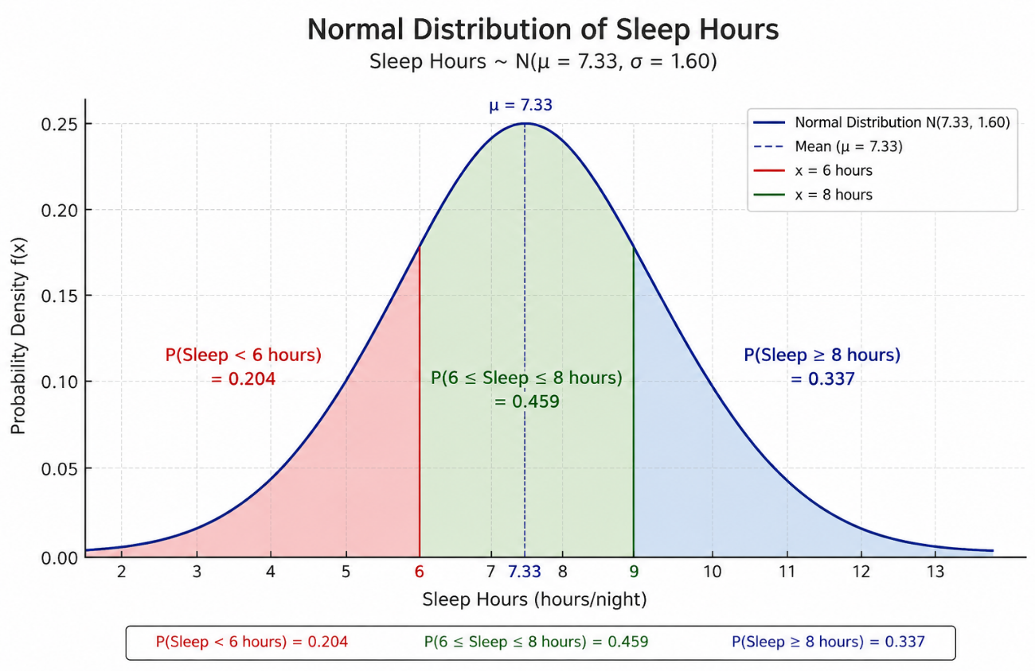

10.2 Poission distribution:

Step 1: Calculate the Poisson Parameter (λ)
For a Poisson distribution:
$$λ=\text{Mean}$$
Mental Health Scores:
$$2,3,3,4,4,5,5,5,6,6,6,7,7,7,8,8,8,8,8,8,9,9,9,9,9,9,10,10,10,10$$
Sum:
$$∑x=214$$ Sample size:
$$n=30$$
Mean:
$$λ=\overset{ˉ}{x}=\frac{214}{30} \\ λ=7.13$$

Poisson Distribution Formula

where
- $x$= Mental Health Score
- $λ=7.13$

Calculation:
Sum (Σx) = 212
Sample size (n) = 30
λ = 212 / 30 = 7.0667

Poisson Distribution Formula
P(X = k) = (e⁻λ × λᵏ) / k!

Where:
- X = Mental Health Score (the random variable)
- λ = 7.0667 (the Poisson parameter / mean)
- k = specific value (1 to 10)
- e = 2.71828... (Euler's number)
- k! = k factorial (k × (k-1) × (k-2) × ... × 1)
4. Poisson Probability Distribution Table
Calculated for each mental health score (k = 1 to 10) with λ = 7.0667:

k (Score) | P(X = k) | Expected Frequency | Observed Frequency
1 | 0.006028 | 0.18 | 0.0
2 | 0.021300 | 0.64 | 1.0
3 | 0.050174 | 1.51 | 2.0
4 | 0.088641 | 2.66 | 2.0
5 | 0.125279 | 3.76 | 3.0
6 | 0.147551 | 4.43 | 3.0
7 | 0.148956 | 4.47 | 3.0
8 | 0.131578 | 3.95 | 6.0
9 | 0.103313 | 3.10 | 6.0
10 | 0.073008 | 2.19 | 4.0

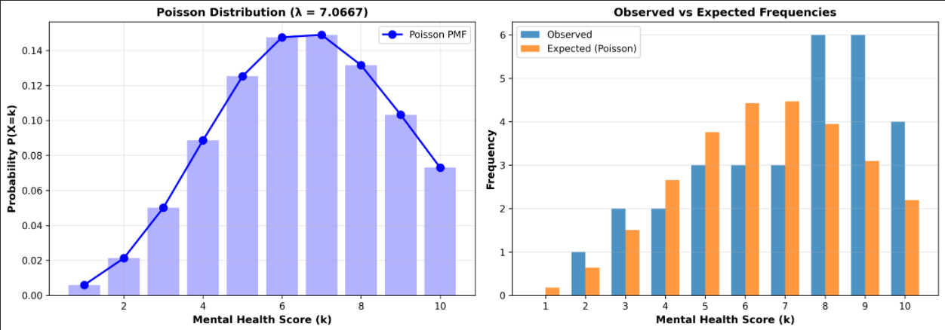

10.3 Binomial Distribution Example
If we define 'success' as achieving good mental health (score ≥ 7), with n = 30 and p = 19/30 = 0.633:
Expected number with good MH = np = 30 × 0.633 ≈ 19 students
Variance = np(1-p) = 30 × 0.633 × 0.367 ≈ 6.97
Standard deviation = √6.97 ≈ 2.64

11.Categorical Data Analysis
11.1 Category Breakdown
Mental Health Score Categories:
Low (1-3): 0 students (0%)
Moderate (4-6): 8 students (27%)
Good (7-9): 13 students (43%)
Excellent (10): 9 students (30%)

Sleep Quality Categories:
Poor (≤6h): 8 students (27%)
Fair (6-7h): 5 students (17%)
Good (7-8h): 7 students (23%)
Excellent (8+h): 10 students (33%)
12. Conclusions & Recommendations

12.1 Key Statistical Findings
1. Sleep Quality Impact: Sleep duration is the strongest predictor of mental health in this cohort
2. Optimal Range: Students averaging 8+ hours show excellent mental health outcomes
3. Risk Group: Students with ≤6 hours of sleep universally experience moderate to low mental health
4. Strong Associations: Anxiety and depression correlations with sleep are nearly perfect (r > 0.98)
5. Population Estimates: With 95% confidence, mean sleep should be 6.7-7.9 hours for optimal mental health

12.2 Recommendations
For Students: Prioritize 7-8+ hours of sleep daily; even 1 hour increase correlates with measurable improvements in mental health
For Institutions: Implement campus sleep hygiene programs; consider how class schedules affect student sleep
For Mental Health Services: Screen sleep patterns as an early indicator of mental health risks
For Future Research: Longitudinal studies to establish causation; explore mediating factors

13. Key Findings :

1. Variables and Data
- n = 30 students
- 5 Variables: Sleep Hours, Sleep Quality, Anxiety, Depression, Mental Health

2. Frequency Distribution
- Mental Health: Bimodal at 8 & 9 (86.67% high values)
- Sleep: Poor (26.67%) → Excellent (33.33%)

3. Measures of Central Tendency
- Sleep: Mean 7.33, Median 7.50, Mode 8.0
- Mental Health: Mean 7.07, Median 8.00, Mode 8.0

4. Measures of Dispersion
- Sleep Std Dev: 1.60 (lowest)
- Depression Std Dev: 2.39 (highest)

5. Five-Number Summary
- Sleep: Min 4.0, Q1 6.13, Median 7.5, Q3 8.5, Max 10.0
- Outliers: Zero detected

6. Probability Analysis
- Addition Rule: P(A ∪ B) = 0.5333 (53.33%)
- Multiplication Rule: P(A ∩ B) = 0.4667 (46.67%)
- Conditional Prob: P(MH≥8 | Sleep≥8) = 100%
- Bayes Theorem: P(Sleep≥8 | MH≥8) = 87.5%

7. Contingency Table
- P(Good MH | Good Sleep 7-8h) = 100%
- ≥7 hrs sleep = ZERO low MH scores

8. Normality Testing
- Sleep Hours: Nearly normal (p = 0.375) ✓
- Others: Non-parametric tests needed

9. Confidence Intervals (95%)
- Sleep Hours: [6.74, 7.93]
- Mental Health: [6.20, 7.93]

10. Probability Distributions
- Normal: P(Sleep ≥ 8) = 33.7%
- Poisson (Mental Health): λ = 7.0667, Most likely k=7 (14.9%)
- Chi-Square: 7.0837 → Excellent fit ✓
- Binomial: Expected good MH = 19 students

11. Categorical Analysis
- Good + Excellent MH: 73%
- Excellent Sleep (8+h): 33%

14. Python Output:

